Derik Schrader
Professor Cassens
Creative Coding 1
August 31, 2020

Learning Style
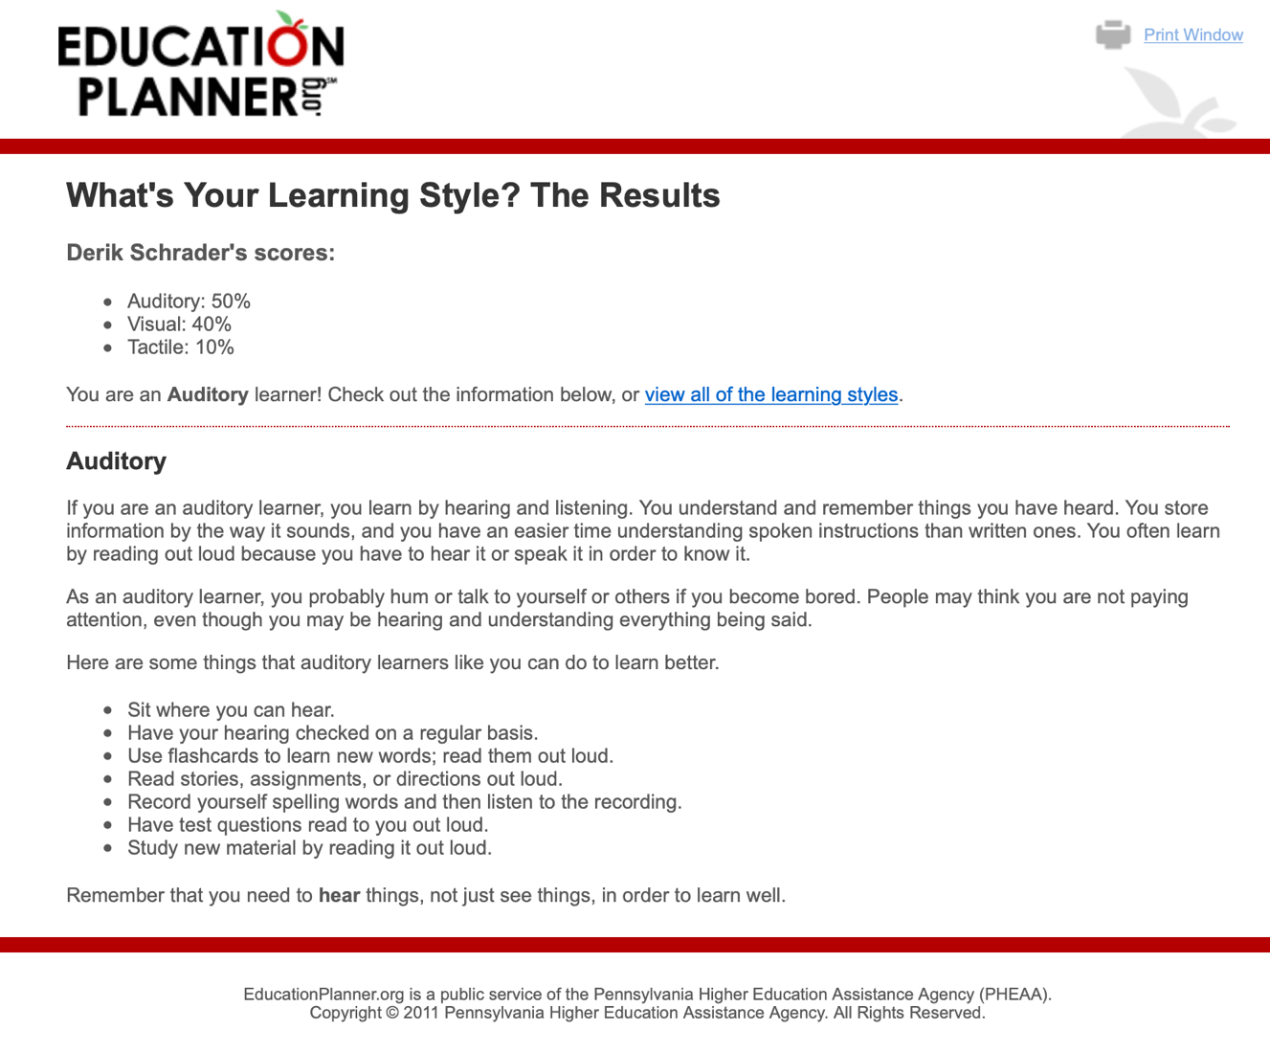
My results from the Learning Style quiz showed that I was an auditory learner, followed by visual and tactile. While this may be true in some aspects, I feel like it varies with different learning situations as I am more of a combination of tactile and auditory. For previous classes I used to find PDF versions and utilize a pdf reader in order to listen to course material in combination with hands on. I’m still adjusting to how the U of M does their online classes, but I suspect that I will be doing the same. In the terms of help, I don’t think too much is needed at this point; however, sometimes clarification is needed in order to get past any roadblocks.

